Q2[5-6m]. A file is to be shared among different processes, each of which owns a unique number. The file can be accessed simultaneously by several threads, subject to the following constraint: the sum of the unique numbers owned by the threads (the unique number can be its ID for instance) currently accessing the file must be less than a defined constant MAX_N. Using condition variable to coordinate file access, write the pseudo code for access_file() and finish_access() called by the threads to request and finish file access respectively. Also mention the initialization of any variables.
Ans:
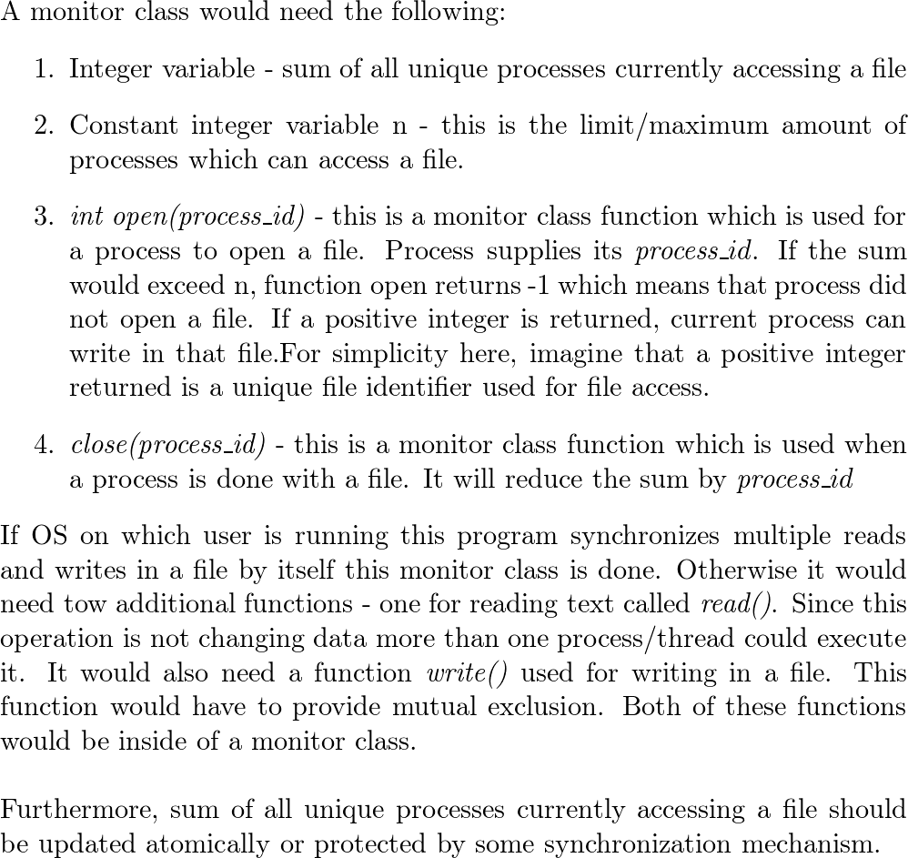

Q) write code for concurrent linked list insertion, search/lookup, delete operation
Or stack (LIFO) DS push and pop operation. Explain the race condition with an example

Q) Consider a roller coaster ride at an amusement park. The ride operator runs the ride only when there are exactly N riders on it. Multiple riders arrive at the ride and queue up at the entrance of the ride. The ride operator waits for N riders to accumulate, and may even take a nap as he waits. Once N riders have arrived, the riders call out to the operator indicating they are ready to go on the ride. The operator then opens the gate to the ride and signals exactly N riders to enter the ride. He then waits until these N riders enter the ride, and then proceeds to start the ride. We model the operator and riders as threads in a program. You must write pseudocode for the operator and rider threads to enable the behavior described above. Shown below is the skeleton code for the operator and rider threads. Complete the code to achieve the behavior described above. You can assume that the functions to open, start, and enter ride are implemented elsewhere, and these functions do what the names say they do. You must write the synchronization logic around these functions in order to invoke these functions at the appropriate times. You must use only locks and condition variables for synchronization in your solution. You may declare, initialize, and use other variables (counters etc.) as required in your solution. /
/operator code, fill in the missing details
.... open_ride() .
... start_ride()
....
//rider thread, fill in the missing details
....
enter_ride()
...
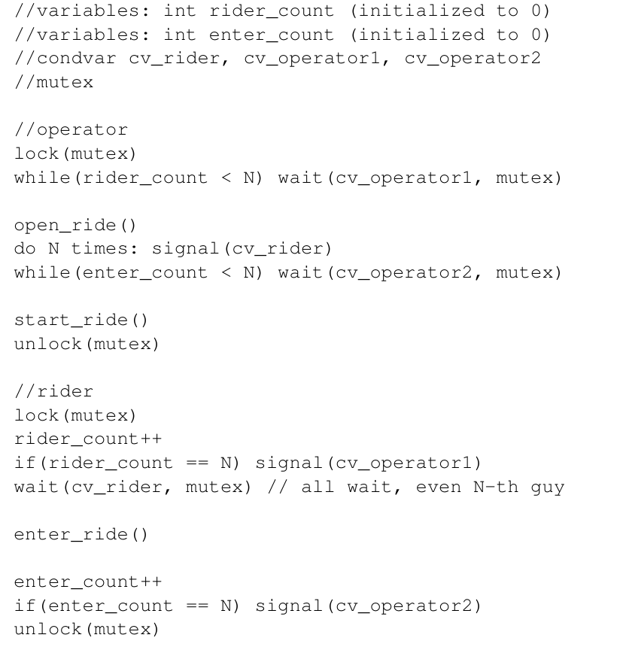
A host of a party has invited N > 2 guests to his house. Due to fear of Covid-19 exposure, the host does not wish to open the door of his house multiple times to let guests in. Instead, he wishes that all N guests, even though they may arrive at different times to his door, wait for each other and enter the house all at once. The host and guests are represented by threads in a multi threaded program. Given below is the pseudocode for the host thread, where the host waits for all guests to arrive, then calls openDoor(), and signals a condition variable once. You must write the corresponding code for the guest threads. The guests must wait for all N of them to arrive and for the host to open the door, and must call enterHouse() only after that. You must ensure that all N waiting guests enter the house after the door is opened. You must use only locks and condition variables for synchronization. Thefollowing variables are used in this solution: lock m, condition variables cv host and cv guest, and integer guest count (initialized to 0). You must not use any other variables in the guest for synchronization.
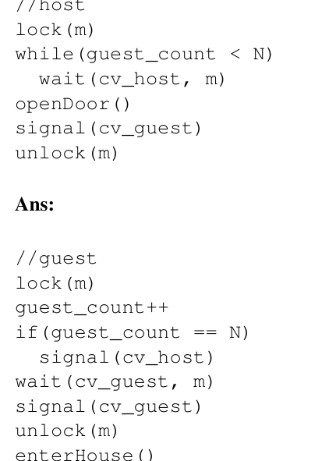

Consider the readers and writers problem as discussed above. We wish to implement synchroniza tion between readers and writers, while giving preference to writers, where no waiting writer should be kept waiting for longer than necessary. For example, suppose reader process R1 is ac tively reading. And a writer process W1 and reader process R2 arrive while R1 is reading. While it might be fine to allow R2 in, this could prolong the waiting time of W1 beyond the absolute minimum of waiting until R1 finishes. Therefore, if we want writer preference, R2 should not be allowed before W1. Your goal is to write down pseudocode for read lock, read unlock, write lock, and write unlock functions that the processes should call, in order to realize read/write locks with writer preference. You must use only simple locks/mutexes and conditional variables in your solution. Please pick sensible names for your variables so that your solution is readable.
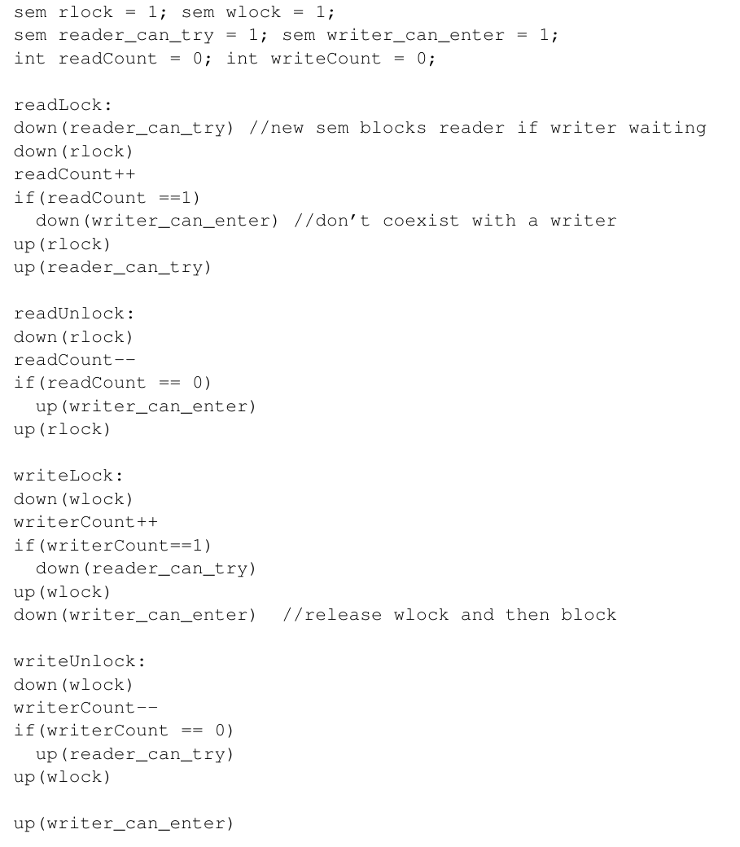
Consider a clinic with one doctor and a very large waiting room (of infinite capacity). Any patient entering the clinic will wait in the waiting room until the doctor is free to see her. Similarly, the the doctor also waits for a patient to arrive to treat. All communication between the patients and the doctor happens via a shared memory buffer. Any of the several patient processes, or the doctor process can write to it. Once the patient “enters the doctors office”, she conveys her symptoms to the doctor using a call to consultDoctor(), which updates the shared memory with the patient’s symptoms. The doctor then calls treatPatient() to access the buffer and update it with details of the treatment. Finally, the patient process must call noteTreatment() to see the updated treatment details in the shared buffer, before leaving the doctor’s office. A template code for the patient and doctor processes is shown below. Enhance this code to correctly synchronize between the patient and the doctor processes. Your code should ensure that no race conditions occur due to several patients overwriting the shared buffer concurrently. Similarly, you must ensure that the doctor accesses the buffer only when there is valid new patient information in it, and the patient sees the treatment only after the doctor has written it to the buffer.
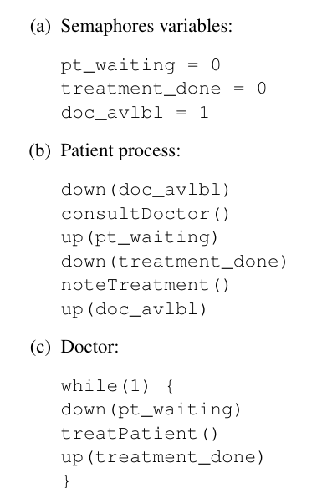
Consider a multithreaded application server handling requests from clients. Every new request that arrives at the server causes a new thread to be spawned to handle that request. The server can provide service to only one request/thread at a time, and other threads that arrive when the server is busy must wait for service using a synchronization primitive (semaphore or condition variable). In order to avoid excessive waiting times, the server does not wish to have more than N requests/threads in the system (including the waiting requests and any request it is currently serving). You may assume that N > 2. Given this constraint, a newly arriving thread must f irst check if N other requests are already in the system: if yes, it must exit without waiting and return an error value to the client, by calling the function thr exit failure(). This function terminates the thread and does not return. When a thread is ready for service, it must call the function get service(). Your code should ensure that no more than one thread calls this function at any point of time. This func tion blocks the thread for the duration of the service. Note that, while the thread receiving service is blocked, other arriving threads must be free to join the queue, or exit if the system is over loaded. After a thread returns from get exit service(), it must enable one of the waiting threads to seek service (if any are waiting), and then terminate itself succesfully by calling the function thr success(). This function terminates the thread and does not return. You are required to write pseudocode of the function to be run by the request threads in this system, as per the specification above. Your solution must use only locks and condition variables for synchronization. Clearly state all the variables used and their initial values at the start of your solution.
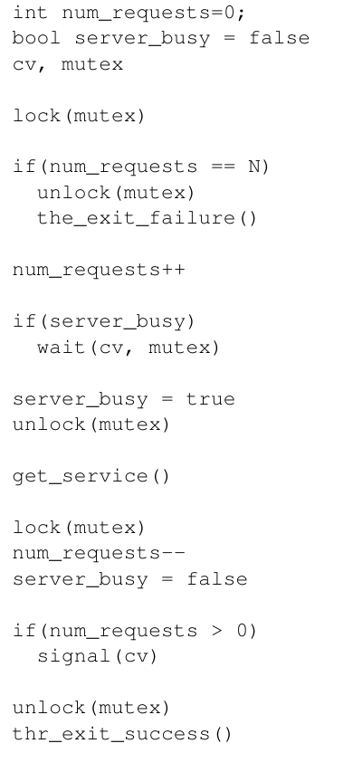
Consider the following synchronization problem. A group of children are picking chocolates from a box that can hold up to N chocolates. A child that wants to eat a chocolate picks one from the box to eat, unless the box is empty. If a child finds the box to be empty, she wakes up the mother, and waits until the mother refills the box with N chocolates. Unsynchronized code snippets for the child and mother threads are as shown below: //Child while True: getChocolateFromBox() eat() //Mother while True: refillChocolateBox(N) You must nowmodifythe code of the mother and child threads by adding suitable synchronization such that a child invokes getChocolateFromBox() only if the box is non-empty, and the mother invokes refillChocolateBox(N) only if the box is fully empty. Solve this question using only locks and condition variables, and no other synchronization primitive. The following variables have been declared for use in your solution. int count = 0; mutex m; // you may invoke lock and unlock condvar fullBox, emptyBox; //you may perform wait and signal //or signal_broadcast.
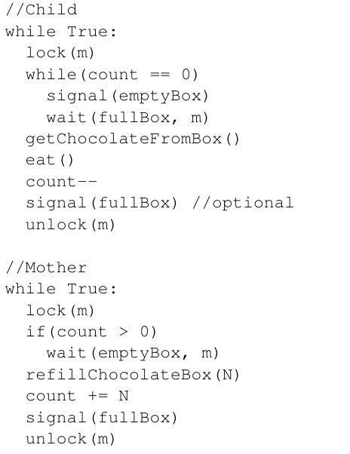
Consider a web server that is supposed to serve a batch of N requests. Each request that arrives at the web server spawns a new thread. The arriving threads wait until N of them accumulate, at which point all of them proceed to get service from the server. Shown below is the code executed by each arriving thread, that causes it to wait until all the other threads arrive. The variable count is initialized to N. The code also uses wait and signal primitives on a condition variable; and you may assume that the signal primitive wakes up all waiting threads (not just one of them). lock(mutex) count--; unlock(mutex) if(count > 0) { lock(mutex) wait(cv, mutex) unlock(mutex) } else { lock(mutex) signal(cv) unlock(mutex) } ... wait done, proceed to server ... You are told that the code above is incorrect, and can sometimes cause a deadlock. That is, in some executions, all N threads do not go to the server for service, even though they have arrived. (a) Using an example, explain the exact sequence of events that can cause a deadlock. You must write your answers as bullet points, with one event per bullet point, starting from threads arriving in the system until the deadlock. (b) Explain how you will fix this deadlock and correct the code shown above. You must retain the basic structure of the code. Indicate your changes next to the code snippet above.
Ans: The given incorrect solution may cause a missed wakeup. For example, some thread decides to wait and goes inside the if-loop, but is context switched out before calling wait (and before it acquires the lock). Now, if count hits 0 and signal happens before it runs again, it will wait with no one to wake it up, leading to deadlock. The fix is simply holding the lock all through the condition checking and waiting.
Consider an application that has K + 1 threads running on a Linux-like OS (K > 1). The first K threads of an application execute a certain task T1, and the remaining one thread executes task T2. The application logic requires that task T1 is executed N > 1 times, followed by task T2 executed once, and this cycle of N executions of T1 followed by one execution of T2 continue indefinitely. All K threads should be able to participate in the N executions of task T1, even though it is not required to ensure perfect fairness amongst the threads. Shown below is one possible set of functions executed by the threads running tasks T1 and T2. You are told that this solution has two bugs in the code run by the thread performing task T2. Briefly describe the bugs in the space below, and suggest small changes to the corresponding code to fix these bugs (you may write your changes next to the code snippet). You must not change the code corresponding to task T1 in any way. All threads share a counter count (initialized to 0), a mutex variable m, and two condition variables t1cv, and t2cv. Here, the function signal on a condition variable wakes up only one of the possibly many sleeping threads.
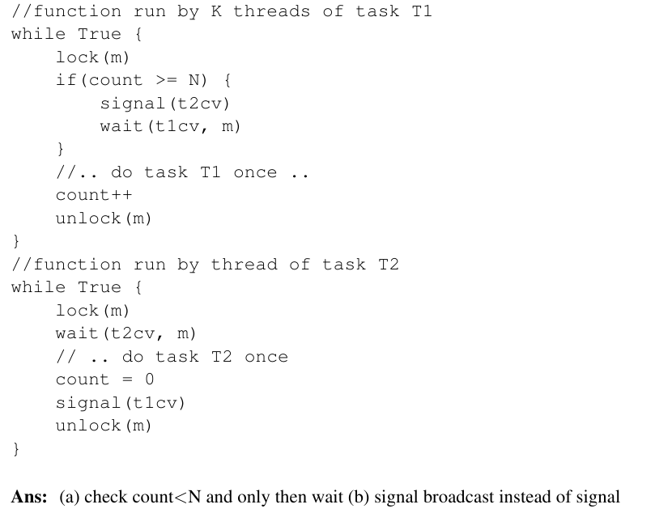
A number of threads periodically call into the following routine, to make sure that a pipe that is shared between them has already been opened (after calling this routine, a thread might go ahead and call write() on that pipe, for example). Assume there is a global integer pipe, which is set to -1 when the pipe is closed, and a global lock lock, which is used for synchronization. Here is the code:
void MakeSurePipeIsOpen()
{ mutex_lock(&lock);
if (pipe == -1) pipe = open(‘‘/tmp/fifo’’, O_WRONLY);
mutex_unlock(&lock); }
However, you get clever, and decide to re-write the code as follows:
void MakeSurePipeIsOpen() {
if (pipe == -1) {
mutex_lock(&lock); if (pipe == -1) pipe = open(‘‘/tmp/fifo’’, O_WRONLY);
mutex_unlock(&lock); }
}
Does this code still work correctly? If so, what advantage do we gain by using this implementation? If not, why doesn’t it work?

Suppose two threads execute the following C code concurrently, accessing shared variables a, b, and c:
Initialization
int a = 4; int b = 0; int c = 0;
Thread1
if (a < 0) { c = b - a; } else { c = b + a; }
Thread 2
b = 10; a = -3;
What are the possible values for c after both threads complete? You can assume that reads and writes of the variables are atomic, and that the order of statements within each thread is preserved in the code generated by the C compiler. For each value derived, show the instruction interleaving order too.
Answer: 4, 7, 13, 14, -3

What are the main conditions that an efficient lock is expected to fulfill?

Answer:

- The first and foremost task of a lock is to provide mutual exclusion (i.e. preventing multiple threads from entering a critical section).
- To make sure that each thread contending for the lock get a fair shot at acquiring it once it is free. None of the threads starve.
- Finally check its performance. There are two cases here. First, is, when a single thread is running and grabs and releases the lock, what is the overhead of doing so? Another is the case where multiple threads are contending for the lock on a single CPU.

Answer:

- The reason is that the wait call, in addition to putting the calling thread to sleep, releases the lock when putting told the caller to sleep.
- Otherwise how could another thread acquire the lock and signal it to wake up?
- However, before returning after being woken, the pthread_cond_wait() re-acquires the lock, thus ensuring that anytime the waiting thread is running between the lock acquired at the beginning of the wait sequence and the lock release at the end, it holds the lock.
When a condition variable is signaled on, and a thread is to be "woken up", two things occur:
- The thread is removed from the wait queue
- The thread reacquires the mutex
The two steps are logically independent. What this means is that another thread may be given CPU time (and potentially the mutex) in between these two steps. As a result, the shared state may be updated before the waking up thread reacquires the mutex. Therefore, the thread must do another check when it actually acquires the mutex to ensure the condition it needs to proceed is still true.

Consider the methods used by processes P1 and P2 for accessing their critical sections whenever needed, as given below. The initial values of shared Boolean variables S1 and S2 are randomly assigned. Will it work? Justify your answer

Method used by P1 | Method used by P2
while (S1 == S2);  Critical Section  S1 = S2 | while (S1 != S2);  Critical Section  S2 = !S1

State 2 benefits of multithreading? When is it useful to add more threads, when does adding threads lead to pure overhead? What are the possible sources of overhead associated with multithreading?
There are two main benefits of multithreading, namely parallelization and concurrency (on single CPU) i.e is the hiding of I/O latency.
Adding threads make sense if you have fewer threads than you have cores or if you are performing many I/O requests. Adding threads can lead to pure overhead otherwise.
While new threads require less memory than new processes, they still do require memory. This means that threads cannot be made for free, and in fact thread creation is often quite expensive. In addition, thread synchronization can add more overhead to the system, in terms of the CPU cycles and memory that must be consumed to represent and operate synchronously.

There is a boss-workers multithreading pattern. you have one boss thread and n worker threads. For each task that enters the system, the boss dispatches the tasks that the workers consume.This is often, though not necessarily, done through a shared request queue/buffer. In this case, the boss will add items to the queue, and the workers will consume items from the queue.
The other one is the pipelined multithreading pattern. In this, the execution of the task is broken down into stages. Threads are assigned to continually complete the work at one stage, receiving requests from the stage before it and passing work on to the stage after it.
If you need to improve a performance metric like throughput or response time, what could you do in each of the model? What are the limiting factors in improving performance in each of the pattern?
Ans: in boss-worker model, there are mainly two things you could do. First, increase the number of threads. The more you leverage concurrency, the more potential you have to increase the efficiency of your processing. That being said, dynamic thread creation is expensive, so it makes sense to just have a pool of workers up front instead of creating new threads on the fly. Increasing the size of the pool may help performance.
Second, decrease the amount of work the boss has to do. Since the boss has to do some processing on every request, the throughput of the system is correlated to this processing time. Make sure to make this is low as possible.
This approach is still limited by the amount of processing power you have. After a certain number of threads, the work will become CPU-bound. Some threads will end up just having to wait their turn for computing resources.
In addition, this approach lacks locality. The boss doesn't keep track of what any of the workers were doing last. It is possible that a thread is just finishing a task that is very similar to an incoming task, and therefore may be best suited to complete that task. The boss has no insight into this fact.

In pipelined pattern, the benefits is locality. Since each thread performs the same (small) task over and over again, it is more likely that the hardware cache will be hot, increasing performance.
On a larger level, this pattern will be bottle necked by the stage that takes the longest to complete. One way to overcome the difference in processing needed for each stage is to allocate a different number of threads to each stage. For example, a stage that takes three times as long as another stage should have three times the amount of threads.
A downside of this approach is that it is difficult to keep the pipeline balanced over time. When the input rate changes, or the resources at a given stage are exhausted, rebalancing may be required.

